
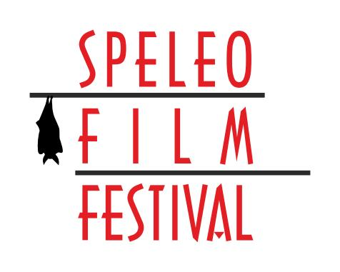
SPELEO FILM FESTIVAL
Karlovac, 24.September 2016.

APPLICATION FORM
Application deadline: 15.09.2016.
Please send completed application forms by e-mail to: info.speleofilmfestival@gmail.com or by post to:
Osmica Karlovac, Bašćinska cesta 3, 47000 Karlovac, Croatia

ORIGINAL TITLE:
DURATION: |  | IN MINUTES | COUNTRY OD ORIGIN:
AUTHOR(S):
ADDRESS: |  |  | CITY:
POSTAL CODE: |  |  | COUNTRY:
PHONE/MOBILE NUMBER: |  |  | E-MAIL:
NAME OF ASSOCIATION (CLUB, ORGANIZATION,ETC.):
ADDRESS: |  |  | CITY:
POSTAL CODE: |  |  | COUNTRY:
PHONE/MOBILE NUMBER: |  |  | E-MAIL:
COPYRIGHTS:
NAME OF ASSOCIATION (CLUB, ORGANIZATION,ETC.):
BY ENTERING THE FESTIVAL, AUTHORS GIVE PERMISSION TO PRESENT THEIR FILMS AT THE SPELEO FILM FESTIVAL 2016, AS WELL AS TO USE THEM TO PROMOTE THE FESTIVAL.
FILM SUMMARY:

Author's signature:

_________________________________

In,___________________,(date)_________________2016.

